Post Lab Questions
- The academic officer also wants to make sure no one insert, update or deletes department information from the database. As university has only 3 departments CS, Business and Electrical and that are already present in database. So, create a trigger that will not let anyone to change the department table.
create trigger T_NoChangeInDeparment
on t_department
instead of insert, delete, update
as
print 'CAN NOT MODIFY DEPARTMENT'

select * from t_department

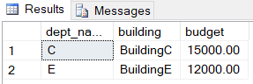

insert into t_department(dept_name, building, budget)
values('EE', 'BuildingEE', 20000)

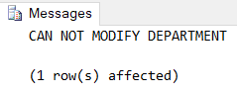

update t_department set budget = 25000 where dept_name = 'C'

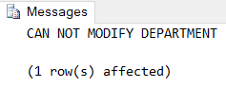

delete from t_department where dept_name = 'C'

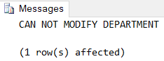
select * from t_department

- The academic officer was very happy with your last changes in university database So he hires you again on contract basis to make few more changes to database. So, perform following changes to the university database.
- The audit log we made will be useless if someone delete the record from it. So, he wants to have a security measure on the table so that no one is able to delete any record or update any record from the Auditing table.

create trigger T_NoChangeInAuditing
on Auditing
instead of delete, update
as
print 'CAN NOT DELETE OR UPDATE AUDITING'

select * from Auditing

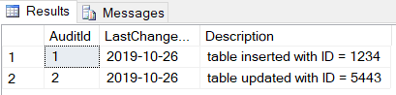

update Auditing set LastChangeOn = '2019-10-27' where AuditId = 2

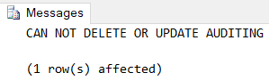

delete from Auditing where AuditId = 1

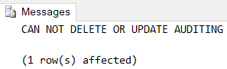

select * from Auditing

